Class Registration application

Create an application that registers students for a class.

## REQUIREMENTS

* Students should be able to view class schedules.
* Students should be able to add class to take.
* Students should be able to drop a class and the registrar makes a confirmation.
* Students should be able to view all the classes that they are taking.

## Use Case Diagram

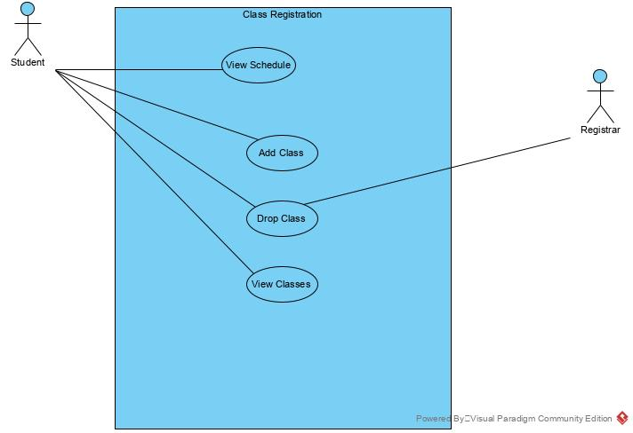

# Class diagram

